Instructions:

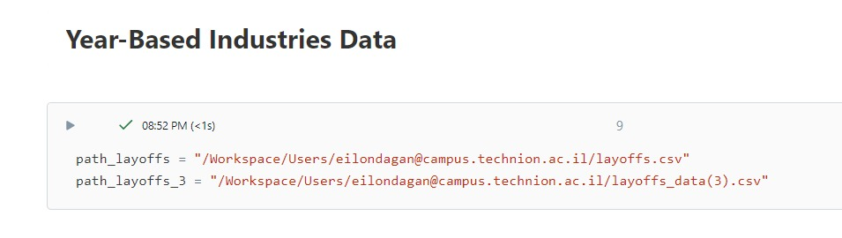

Put the additiona data paths in this part of the note book than run the code